**Advanced Programming Practices**

Hackerrank Week-10

Name: Ronit Kumar Reg: RA2111032010009 Section: T2 Branch:CSE w/s OT

**Ques 1:** The Bomberman Game

**Problem:**

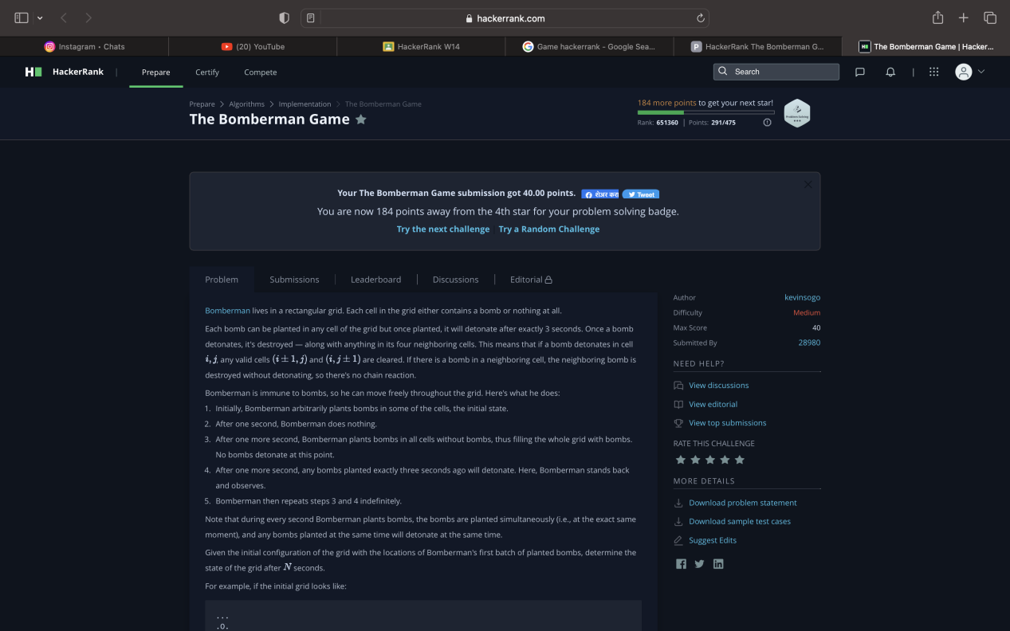

**Code:**

**def** bomb(b,r,c):

    field = [['O' **for** i **in** **range**(c)] **for** j **in** **range**(r)]

**for** i **in** **range**(r):

**for** j **in** **range**(c):

**if** b[i][j] == 'O':

                field[i][j] = '.'

**if** i+1<r:

                    field[i+1][j] = '.'

**if** i>0:

                    field[i-1][j] = '.'

**if** j+1<c:

                    field[i][j+1] = '.'

**if** j>0:

                    field[i][j-1] = '.'

**return** field

r,c,n = **input**().split()

r,c,n = **int**(r),**int**(c),**int**(n)

b = []

**for** i **in** **range**(r):

        row = **list**(**input**())

        b.append(row)

**if** n%2==0:

    f = [['O' **for** i **in** **range**(c)] **for** j **in** **range**(r)]

**for** i **in** **range**(r):

**print**(''.join(**map**(**str**,f[i])))

**else**:

    bombed1 = bomb(b,r,c)

    bombed2 = bomb(bombed1,r,c)

**if** n==1:

**for** i **in** **range**(r):

**print**(''.join(**map**(**str**,b[i])))

**elif** (n+1)%4==0:

**for** i **in** **range**(r):

**print**(''.join(**map**(**str**,bombed1[i])))

**elif** (n+2)%4==0:

**for** i **in** **range**(r):

**print**(''.join(**map**(**str**,b[i])))

**else**:

**for** i **in** **range**(r):

**print**(''.join(**map**(**str**,bombed2[i])))

**Output:**

